The Possum Plague: Disease Dynamics

Group 7: Khalil Salhat Saleh, Jacob Alspaw

1 December 2014

MATH 224: Differential Equations - David Gurarie

**Abstract**

In the 1830’s, the ecosystem of New Zealand was introduced to a species of possum, *Trichosulrus vulpecula*. Fur-traders of Australia believed the introduction of the possum would stimulate the fur-trade economy within the region. However, the possum population, lacking a natural predator, exponentially increased to its current size of seventy-million. This population of possum, being susceptible to bovine tuberculosis, has turned into a virus reservoir. Within the article “Percy Possum Plunders” by Graeme Wake, Wake studies the effect these possums have had on the ecosystem of New Zealand. Wake and his peers believe approximately half of the population of possums living on the island of New Zealand are infected with this deadly virus. The population’s mass infection poses a serious and immediate risk to New Zealand’s agricultural economy; the disease, when transferred to healthy livestock, given a certain amount of time produces an infected herd and, therefore, loss of profit.

To understand the spread of this disease, scientists have created a differential system that incorporates the natural birth and death rates, the rate of infectivity from sick to healthy possum, and the rate at which the infected possums die from the disease. The system of equations allows us to investigate this real-life scenario and observe how relationships between certain factors can change the spread of a disease.

Our group noticed the increase of variable c (intrinsic natural growth) caused an equilibrium shift in the directions of increasing x and y values. This correlation proved true until intrinsic growth rate reached the value of one. While intrinsic growth rate is increasing and equal to or greater to the value one, the system reaches a state where an increase in the intrinsic growth rate leads to an increase in the number of infected possum and the ratio of healthy to infected possum decreases.

**Main Body**

The system modeling the possum population for New Zealand is shown below:

**Change of Total Population P’ = (a - b) P - u I**

**Change of Infected Population I’ = VI (P-I)- (u+b) I**

The components of the system are labeled as is: “a” is the natural birth rate, “b” is the natural death rate, “u” is the disease mortality rate, “v” is the infection rate, and “vI(P - I)” represents the infection of animals (proportional to the contacts between healthy and infected possums).

The system our group used to explain this situation is a scaled version of the original model seen above. This version directly incorporates the biological factors of the system.

**Change of Total Population x’ = c x - d y**

**Change of Infected Population y’ = y (x - y) - r y**

The components of this system relate to the components of the previous system: “c” or (a - b)/v is the intrinsic natural growth, “d” or u/v is the disease induced attrition, and “r” or (u + b)/v is the combined attrition

To understand how the system works, our group plotted the phase plane, equilibria points, and direction field of the system with several different values for c and r. We decided to keep the value of d, disease induced attrition, equal to one as it represents the rate at which the possum are dying in relation to how fast they are being infected. The disease induced attrition value cannot change drastically unless the biology of the disease itself changes. The disease would need to mutate in such a way that the dominant strain acquires or loses a characteristic. If the virus were to become more transmissible and say become airborne, then infectivity would increase and disease induced attrition would decrease. If the disease we’re to start causing necrosis, then the mortality rate would surely increase and disease induced attrition would increase.

The first case our group examined was when **c = 0** and **r = 2** with a fixed value **d = 1**. Our group found that this system doesn’t work. If this was true, according to the system we would have zero possums on New Zealand which we know not to be true . If intrinsic natural growth is zero and combined attrition is positive, the population of possums is on a path to local extinction.

The next case our group inspected was **c = 1.5** and **r = 2** with our fixed value **d = 1:** 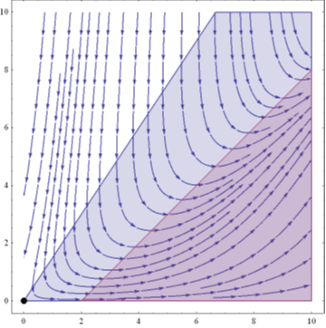

In this case we only have our trivial unstable saddle equilibria point at zero. This trivial point is common in such a system because at time t = 0, there is no change in a population because no actions or change have occurred beforehand. Since this disease is incurable in possums and none survive the disease. We can see from the phase lines and solution curves that given enough time all the healthy possum will become infected and eventually die. Another thing to notice is that no possum will die of natural causes before they get infected.

The next case our group analyzed was when **c = .25** and **r = 2** with fixed value **d=1:**

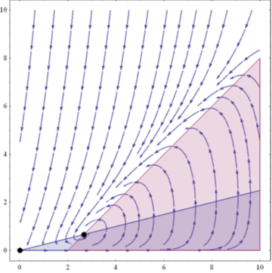

For this case, the system has two equilibria points. The point at (x , y) = (0 , 0) is our trivial unstable saddle equilibria point and the other at approximately (x , y) = (2.5 , 0.5) is a spiral sink where the two nullclines cross. The spiral sink equilibria corresponds to when we no longer have any more possums getting infected and there are a stable number of healthy and infected possums. This is the definition for our equilibria; there is no change between the healthy and sick population magnitude. Because the possums are unable to recover from the virus, we can infer from the system that the number of possums dying and the number of possums being infected are at equilibrium with the intrinsic growth rate of the total population.

The next case we looked at was when **c = 1** and **r = 2** with fixed value **d=1:** 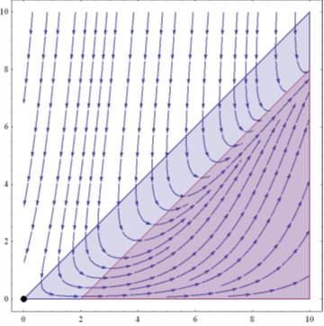

For this case, the system is back to having one equilibrium point. It is the trivial equilibrium. When intrinsic natural growth reaches a value of one, the system reaches a turning point where there is a loss an equilibrium. At this case is when the nullclines are parallel so no possum will die without being infected first.

The next case we looked at was when **c = 10** and **r = 2** with fixed value **d=1:**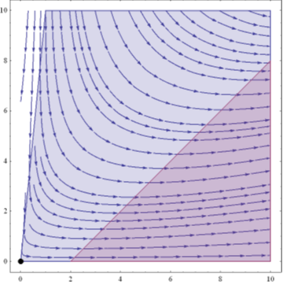

Again, when intrinsic natural growth is greater than or equal to zero, the only equilibrium point the system contains is the trivial equilibrium. As it is true for all cases of c is greater than or equal to one, the system will always have only the trivial equilibria. As c increases, the nullclines widen in an accelerating fashion, effecting the direction field to tend more towards a horizontal direction. At this value of c, much of the possum population becomes infected and it tends toward death. Because the disease induced attrition is indirectly proportional to the infectivity (as c increases, more infections occur), we can conclude from the system the infected possum population will have an increasing ratio of infected possums to dead possums.

The next case we looked at was when **c = .5** and **r = 10** with fixed value **d=1:**

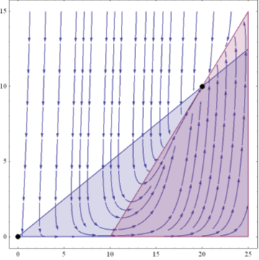

Since intrinsic natural growth rate is less than one, the system has two equilibria points; one is the trivial at (x , y) = (0 , 0) and the other is a sink where all the solutions tends toward. The increase in r shifts the x - intercept of the red nullcline, widening the region of infected possum. This is supported by our system of equations because an increase in disease induced attrition coincides with a greater rate of mortality as seen in the phase plane.

As is true for all cases of increase in c, the nullcline for the infected possum population will increase in slope. As slope increases, more possums of the total population are infected over a certain period of time. Additionally, as is true for all cases of increase in r, the nullcline for the deceased possum population will increase in slope. As slope increases, more possums from the infected population will die over a certain period of time. Notice that the phase plane solutions do not allow a crossing between the nullcline region separating the white and red areas above. This is because our system does not allow for possums to recover once infected.

Bifurcations in this system are relatively uncommon. We have already scrutinized different cases for the values seen above. From these cases, we can be sure a bifurcation occurs only when c reaches a value of one. At this point we lose a equilibrium (a shift from two to one equilibria) and a small change in parameter c leads to a drastic change in long-term behavior. There is potential for another bifurcation when c is less than zero, but it can be disregarded; if intrinsic natural growth is negative, then the possum population would, according to our system, unrealistically reach negative values.

Referring back to the original system, our group will explain a method to find the eigenvalues between the sick and healthy population. Remember:

**Change of Total Population P’ = (a - b)P - uI**

**Change of Infected Population I’ = VI(P - I) - (u + b)I**

From this set of equations, it is logical to conclude Total Population is equal to the sum of the infected possum’s population and the healthy possum’s population or P = H + I. The components of the system remain unchanged. We can assume “a” will be greater than “b” so the population will grow exponentially.

If P = H + I , then we can conclude the alternate system

**Change of Healthy Population H’ = (a - b)H + aI - vIH**

**Change of Infected Population I’ = -(u + b)I + vIH**

Through the use of nondimensionalization, our group could rearrange our equation using suitable substitutions for variables. This technique helps us simplify and parameterize the system into the one shown below.

Substitutions: H = (ax - bx)/v and I = (ay - by)/v

**x’ = x + fy - xy**

**y’ = -zy + xy**

***Notice the system modeling infection mimics a system representing the relationship of predator and prey. Both populations are directly dependent of the other’s magnitude: the infected population directly decreases the population of the healthy individuals like that of predators on prey population. Likewise, the population of infected population is directly proportional to size of healthy population. The virus can be thought of as the predator; for every possum the virus metaphorically consumes, the predator population is able to support another member and increases in size.

f = a/(a - b)

z = (u + b)/(a - b)

According to “Percy Possum Plunders,” a is approximately 1.8b, so f is approximately 1.75.

There are two equilibrium solutions for this system: (x , y) = (0 , 0) and (z , (4z)/(4z - 9)). This system can be linearized by finding a linear approximation at a given point. The system is linearized around (x , y) = (X , Y) + (u , v). The system becomes;

**A’ = A + fB**

**B’ = -zB**

which can be assimilated to our equilibria.

**A’ = -9A/(4z - 9) - (4z - 9)B/9**

**B’ = 4zA/(4z - 9)**

This system can be transferred into a matrix solvable for eigenvalues by our methods learned in class. Once the eigenvalues are found, the eigenvectors can also be found, and then used in the solutions for populations of healthy and infected possums. The eigenvalues, in this case will help represent a set value of parameters for which a differential equation has a nonzero solution under our groups given conditions.

**Conclusion**

Exploring the mathematics behind systems of infection dynamics is a critical method to explain an ecosystem. The introduction of the possum did in fact stimulate the fur trade for a desirable amount of time, but has rebounded negatively on New Zealand’s modern economy. With the spread of bovine tuberculosis through a possum vector, herds of livestock have become worthless. A system defining the relationship of the possum epidemic can greatly influence a strategy for handling the spread of disease. Analysis of the system defined by infection of a population can illustrate the long-term spread based on a number of factors. Studying how these factors affect the system could help New Zealand change the long term populations of the possum. If we notice that decreasing the infected population of possums will make this population tend towards zero individuals, then New Zealand could establish an effort to lower the population down to this critical number. This option is a much better solution than completely eradicating the possum population. It would be much more time efficient and cost efficient to exterminate, for example, a fifth less possums. Our group noticed a drastic shift in population change when the intrinsic growth rate reached a value of one. If the growth rate could somehow be controlled and suppressed below this value, the infected possum population could be controlled. Perhaps not the best solution to this notion, but an introduction of hormone suppressant chemicals into the ecosystem could disrupt possum reproduction. Overall, a system of equations proves a useful tool in examination of an ongoing epidemic.

**Appendix**

***See attached papers. These pages show work on how to achieve eigenvalues from the linearized system.